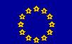 Ref. Ares(2013)1001353 - 03/05/2013
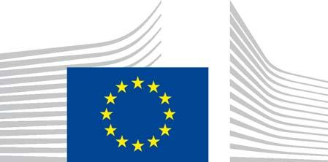
EUROPEAN COMMISSION

HEALTH AND CONSUMERS DIRECTORATE-GENERAL

Health systems and products

Medicinal products – quality, safety and efficacy

Brussels,

SANCO/D/6/SF/mg/ddg1.d.6(2013)1104750

TEMPLATE FOR THE QUALIFIED PERSON'S DECLARATION EQUIVALENCE TO EU GMP FOR INVESTIGATIONAL MEDICINAL PRODUCTS MANUFACTURED IN THIRD COUNTRIES

This document provides the template for the Qualified Person’s Declaration Concerning GMP Compliance of the Investigational Medicinal Products as per Commission guideline CT-1,¹ section 2.7.1, paragraph 62.

The aim is to harmonise this template and hence the dossier submitted with a request for authorisation of a clinical trial.

Document history:

Date of discussion of draft by the ad-hoc group for the
development of implementing guidelines for the “Clinical | 30 April 2013
Trials Directive” 2001/20/EC:
Date of publication: | See above
Date of coming into operation: | 6 months date of publication
Supersedes: | N/A
Changes compared to superseded version: | N/A

- Detailed guidance for the request for authorisation of a clinical trial on a medicinal product for human use to the competent authorities, notification of substantial amendments and declaration of the end of the trial (OJ C82, 30.3.2010, p. 1)

Commission européenne/Europese Commissie, 1049 Bruxelles/Brussel, BELGIQUE/BELGIË - Tel. +32 22991111 Office: DM24 02/034 - Tel. direct line +32 229-67543 - Fax +32 229-98046; Sanco-pharmaceuticals-d6@ec.europa.eu
QUALIFIED PERSON'S DECLARATION EQUIVALENCE TO EU GMP FOR INVESTIGATIONAL MEDICINAL PRODUCTS MANUFACTURED IN THIRD COUNTRIES² (ARTICLE 13(3)(b) OF DIRECTIVE 2001/20/EC)

EudraCT | Name of the IMP(s)
number(s)

Manufacturing and/or Importation Authorisation (MIA) number³ under which this

declaration is made: ____________________________________________

Part A

Name of the | Manufacturing site(s) | Activity performed at
IMP(s) | (Name and address where the | this site
 | activity is performed) | (including packaging,
 |  | labelling and testing)

Part B

I confirm that I am a QP and am authorised to make this declaration.

I declare that compliance with GMP at least equivalent to EU GMP has been verified on the basis of:

(i) | Audit
Manufacturing site(s) |  |  | Auditing party | Date of last audit
(Name and address where the |  |  |  | (completion)
activity is performed)

- Countries other than EU Member States or contracting states of the European Economic Area (EEA).

- If no number is issued please state the name of the authorisation holder.

2
(ii) If an audit of the site has not been performed, please provide a brief justification and explanation on how the QP knows that standards at least equivalent to EU GMP are being followed at the site⁴.

Manufacturing site(s) | Justification

(Name and address where the activity is performed)

This declaration is submitted by:

Signatory ___________________ Date ___________________

Print name ___________________________

- E.g. assessment of documentation provided by the manufacturer, valid GMP certificate (EudraGMP), etc.

3

