Aktualizácia August 2016
[zmeny od poslednej aktualizácie]

The State Institute for Drug Control informs all applicants, that from 2nd of November 2015, it is possible to submit dossiers via the electronic system - CESP Portal.
On our official website www.sukl.sk you can find the updated SK application forms for Marketing Authorisation, for Variation to a Marketing Authorisation type II, IB, IA, for Renewal of Marketing Authorisation and for Variation according to Article 61(3) Directive 2001/83/EC, where it is necessary to fill in a CESP number.
The additional submissions of dossiers (Responses) for various procedures, which were running until now on CD/DVD with the cover letter, it is possible to submit via the CESP portal, too. For such administration, it is necessary to send an e-mail tocesp.responses@sukl.sk with an evidence of number of the Application and the CESP number.
It is necessary that the sequences were in the same format eCTD or NeeS, how you sent to us previously sequences.
Please note, that via the CESP portal it is possible to send Dossiers only in eCTD/Nees format. For more information about the CESP, please contact our employees from the Department of receiving and administrative support.

For more information about PSUR, please click on the next link: http://www.sukl.sk/sk/bezpecnost-liekov/pokyny/informacia-o-povinnosti-mah-predkladat-vsetky-psur-do-centralneho-psur-repozitata-od-13.6.2016?page_id=4181
Please be informed that it is still requested to submit the application forms (both in Slovak and English) and the Proof of Payment in a hard copy. CESP portal is used only for submission of eCTD/Nees sequences which were running until now on CD/DVD.
Also please note that as a date of submission is considered a date, when the application forms and the Proof of Payment were submitted by SIDC. (not the date, when the sequence was placed to CESP)
CESP (Common European Submission Platform) is a portal for mass submission of applications within the EU as well as a platform technologically independent on the type of application that allows the Institute to receive applications and related documents fully in electronic form.
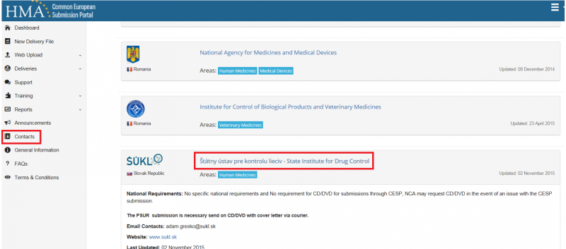
Print page

