 | STATE INSTITUTE FOR DRUG CONTROL  Kvetná 11, 825 08 Bratislava 26, Slovak Republic

Public Assessment Report

Scientific discussion

Moxonidine Saneca 0.2 mg, Moxonidine Saneca 0.3 mg, Moxonidine Saneca 0.4 mg
moxonidine

SK/H/0177/001-003/DC

Date: 12.12.2017

This module reflects the scientific discussion for the approval of Moxonidine Saneca 0.2 mg; Moxonidine Saneca 0.3 mg; Moxonidine Saneca 0.4 mg. The procedures were finalised at Day 208 (24.11.2017). For information on changes after this date please refer to the module ‘Update’.

Introduction

Based on the review of the quality, safety and efficacy data, the Member States (SK, CZ) have granted a marketing authorisation for Moxonidine Saneca 0.2 mg; Moxonidine Saneca 0.3 mg; Moxonidine Saneca 0.4 mg, film-coated tablets from Saneca Pharmaceuticals a.s., Hlohovec, Slovak Republic.
The product is indicated in adults for the treatment of essential hypertension.
A comprehensive description of the indications and posology is given in the SmPC.

The marketing authorisations have been granted pursuant to Article 10(1) of Directive 2001/83/EC.

Quality aspects

Introduction

Moxonidine Saneca is a solid oral dosage form (film-coated tablet). The film-coated tablets are formulated as follows:
0.2 mg are pink, round, biconvex film-coated tablets, with a diameter of 5 mm.
0.3 mg are pink, oblong, biconvex film-coated tablets with a length of 8 mm.
0.4 mg are pink, round, biconvex film-coated tablets, half-scored on one side with a diameter of 7 mm.
The score line is only to facilitate breaking for ease of swalloving and not to divide into equal doses.

Moxonidine Saneca, film-coated tablets are manufactured by wet granulation process followed by compression of tablet cores and film coating. The final container closure system is blister PVC/PVdC/Alu. Carton box has been chosen as a secondary packaging. Shelf-life of 24 months with “Store below 30 °C. Keep the blister in the outer carton in order to protect from light” for the drug product has been approved.

2.2 Drug Substance

Moxonidine (4-Chloro-N-(imidazolidin-2-ylidene)-6-methoxy-2-methylpyrimidin-5-amine):

- Appearance: white or almost white powder.
- Solubility: very slightly soluble in water, sparingly soluble in methanol, slightly soluble in methylene chloride, very slightly soluble in acetonitrile.
Non-chiral molecule.
- Manufacturing: The drug substance, moxonidine, is manufactured by two suppliers Neuland Laboratories and Farmak. Both manufacturers have a valid CEP.
(The role of a Certificate of Suitability (CEP) is to certify the compliance of a material with the requirements laid down in the relevant monograph of the European Pharmacopoeia. Active pharmaceutical ingredients for which a Certificate of Suitability has been granted are suitable for use in medicinal products).
- Specification: The specification is established according to the Ph. Eur. (European Pharmacopoeia) monograph on moxonidine.
- Stability:
- Neuland Laboratories
Based on 48 months stability study data, Neuland proposes the re-test period for moxonidine to be four years, when stored under recommended storage conditions as given on the product label: Preserve in tight containers and store at below 25 °C.
Packaging for moxonidine is proposed as transparent polyethylene bag, strapped and followed by another transparent polyethylene bag, sealed with seal machine and put in a HDPE container.

- Farmak:
The complete stability data have been submitted including accelerated, stress and photostability studies. Moxonidine from Farmak is not sensitive to UV and slightly to thermal degradation. Complete decomposition is observed under acid, alkaline and oxidative conditions.

Medicinal Product

Pharmaceutical development
In order to provide evidence that the products Moxonidine Saneca 0.2 mg/0.3 mg/0.4 mg, film-coated tablets are equivalent to Cynt®0.2/0.3/0.4, the data supporting a waiver drug product of in vivo bioavailability and bioequivalence study have been presented. The test products were compared to the reference products Cynt® 0.2/0.3/0.4, film coated tablets, purchased from Slovak market, marketing authorization holder: BIOMIN a.s., Slovak Republic.
All ingredients used (lactose monohydrate, lactose monohydrate spray dried, crospovidone, povidone,
magnesium stearate, Opadry white 03B28796 and Opadry brown 02F23883) are well known and widely used as pharmaceutical excipients and comply with the relevant pharmacopoeial monographs. Three differences were observed in comparison of the qualitative composition to Cynt®: talc and ethyl cellulose are present in the originator product and iron oxide yellow is only in the test product. The dissolution profiles of developed product is rapidly dissolving (more than 85% of API (active pharmaceutical ingredient) is dissolved within 15 minutes) and are comparable with dissolution profiles of reference products Cynt® 0.2 /0.3/0.4 through the physiological pH range.

Manufacturing
Manufacturer of the drug product is Saneca Pharmaceuticals a.s. Moxonidine Saneca 0.2 mg/0.3 mg/0.4 mg, film-coated tablets are manufactured by wet granulation process followed by compression of tablet cores and film coating. The manufacturer is responsible for manufacturing, primary and secondary packaging, batch control and batch release.

Stability of the product
Shelf-life of 24 months with “Store below 30 °C. Keep the blister in the outer carton in order to protect from light” for the drug product has been approved.

Discussion on chemical, pharmaceutical and biological aspects

A post approval commitment has been made by applicant in order to response to quality issue identified as a major one. Performing a process validation on whole production scale for all strengths post authorisation. The commercial batches will be produced on the same or equivalent equipments operating on the same principle and each production scale will be validated. Applicant commited to perform a validation process right after manufacturing of commercial batches.

Non-clinical aspects

Introduction

Pharmacodynamic, pharmacokinetic and toxicological properties of moxonidine are well known. As moxonidine is a widely used, well-known active substance, the applicant has not provided additional studies and further studies are not required. Overview based on literature review is, thus, appropriate.

Ecotoxicity/environmental risk assessment (ERA)

Moxonidine Saneca is intended for generic substitution, this will not lead to an increased exposure to the environment. An environmental risk assessment is therefore not deemed necessary.

Clinical aspects

Introduction

The applicant sought biowaiver according to the Appendix III of the European Medicines Agency (EMA) Guideline on the investigation of bioequivalence (CPMP/EWP/QWP/1401/98 Rev. 1/Corr**). This type of biowaiver is based on the classification of the substance within the Biopharmaceutics Classification System (BCS) and applies for highly soluble drug substances with known human absorption (BCS classes I or III) and considered not to have a narrow therapeutic index. Moxonidine is claimed to belong to BCS class I, which encompasses substances with a proven high solubility and complete absorption.
When combined with the in vitro dissolution of the drug product, the BCS takes into account three major factors that govern the rate and extent of drug absorption from immediate-release solid oral dosage forms, namely:
- dissolution;
- solubility;
- intestinal permeability.
The main objective of the drug development was to confirm the BCS class I status of moxonidine as well as the high solubility, high permeability and very rapid in vitro dissolution characteristics of moxonidine medicinal products, i.e., the major factors governing the rate and extent of drug absorption from the immediate-release solid oral form of drug products. Moxonidine medicinal products match all the above listed conditions.

The dissolution profiles of developed products are rapidly dissolving (more than 85% of API is dissolved within 15 minutes) and are comparable with dissolution profiles of reference products Cynt® 0.2 /0.3/0.4 through the physiological pH range (please see below Tab. 1-3).

Tab. 1 Data from the twelve units of the test and reference drug products (0.2 mg strengths) through the physiological range of pH
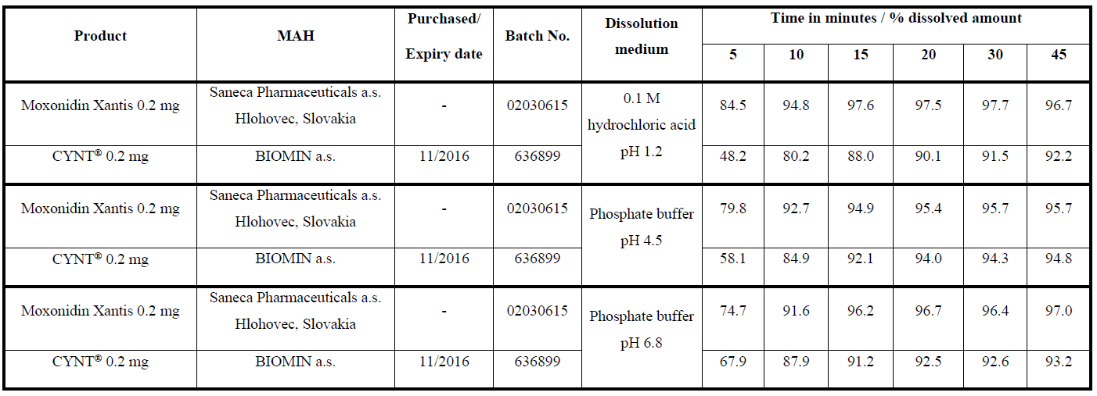

Tab. 2 Data from the twelve units of the test and reference drug products (0.3 mg strengths) through the physiological range of pH

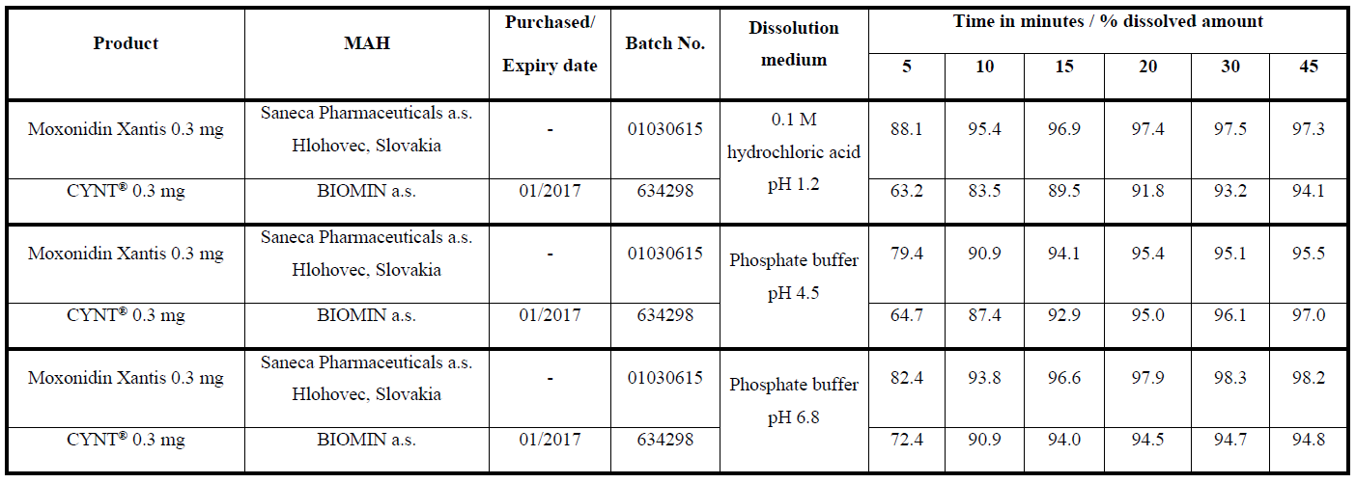

Tab. 3 Data from the twelve units of the test and reference drug products (0.4 mg strengths) through the physiological range of pH

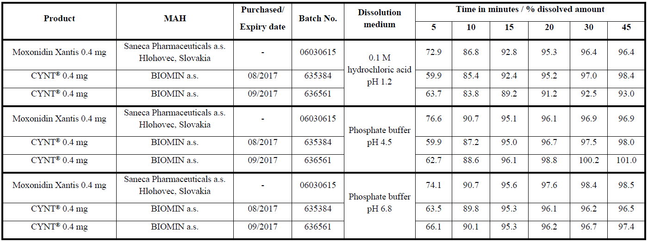

Pharmacokinetics

No pharmacokinetic studies have been submitted.

Risk Management Plan

The Applicant Saneca Pharmaceuticals a.s., Hlohovec has submitted a risk management plan version 01 dated 10.09.2016 with data lock point for this RMP 31.07.2016, in accordance with the requirements of Directive 2001/83/EC as amended, describing the pharmacovigilance activities and interventions designed to identify, characterise, prevent or minimise risks relating to generic product Moxonidin Saneca 0.2 mg, 0.3 mg and 0.4 mg, film-coated tablets.
With the responses to the list of questions raised on the day 70 and 100, the Applicant has submitted the updated RMP version 01.01 signed 23/06/2017.

Safety specification

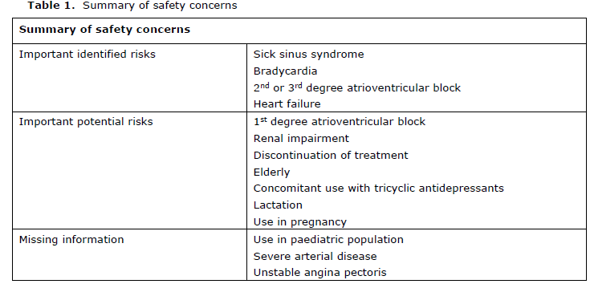

Pharmacovigilance Plan
Routine pharmacovigilance is suggested and no additional pharmacovigilance activities are proposed by the applicant, which is endorsed.

Risk minimisation measures
Routine risk minimisation is suggested and no additional risk minimisation activities are proposed by the applicant, which is endorsed.

User consultation

The package leaflet has been evaluated via a user consultation study in accordance with the requirements of Articles 59(3) and 61(1) of Directive 2001/83/EC. The language used for the purpose of user testing the PIL was English.
The results show that the package leaflet meets the criteria for readability as set out in the Guideline on the readability of the label and package leaflet of medicinal products for human use.
The user testing of 22 tested subjects showed that all participants were able to find the correct section and gave the correct answer. Majority of the tested subjects evaluated the tested package leaflet as understandable, one subject considered the package leaflet too long and with more information. In this case, it is not possible to shortened package leaflet, as it contains all relevant information with regard to SmPC. Some subjects (7 individuals) considered the font too small however the used font is in the line with the guidelines.
The final package leaflet meets the needs of the patients and it enables to use the medicinal product safely and effectively.

Overall conclusion, benefit/risk assessment and recommendation

The benefit risk assessment was considered positive. Therefore the RMS recommended approval of Moxonidine Saneca 0.2 mg; Moxonidine Saneca 0.3 mg; Moxonidine Saneca 0.4 mg.

Post approval commitment not falling under Article 21a or 22 should be included, e.g. as follows:

Description | Due date
Performing a process validation on whole production scale for all strengths post authorisation. The commercial batches will be produced on the same or equivalent equipments operating on the same principle and each production scale will be validated. | Right after manufacturing of commercial batches

