CMDh/223/2005
February 2014

Public Assessment Report

Scientific discussion

Vixargio
rivaroxaban

SK/H/0260/001-005/DC

Date: 03/2023

This module reflects the scientific discussion for the approval of Vixargio. The procedure was finalised at 10.03.2022. For information on changes after this date please refer to the module ‘Update’.

Introduction

Based on the review of the quality, safety and efficacy data, the Member States have granted a marketing authorisation for:

Vixargio 2.5 mg film coated tablets
Vixargio 10 mg film coated tablets
Vixargio 15 mg film coated tablets
Vixargio 20 mg film coated tablets
Vixargio 15 mg film coated tablets, Vixargio 20 mg film coated tablets (treatment initiation pack).

from VIATRIS LIMITED, Dublin, Ireland.

The product is indicated for:

2.5 mg
Co-administered with acetylsalicylic acid (ASA) alone or with ASA plus clopidogrel or ticlopidine, is indicated for the prevention of atherothrombotic events in adult patients after an acute coronary syndrome (ACS) with elevated cardiac biomarkers.

Co-administered with acetylsalicylic acid (ASA), is indicated for the prevention of atherothrombotic events in adult patients with coronary artery disease (CAD) or symptomatic peripheral artery disease (PAD) at high risk of ischaemic events.

10 mg
Prevention of venous thromboembolism (VTE) in adult patients undergoing elective hip or knee replacement surgery.

Treatment of deep vein thrombosis (DVT) and pulmonary embolism (PE), and prevention of recurrent DVT and PE in adults. (See section 4.4 for haemodynamically unstable PE patients.)

15 mg and 20 mg
Adults
Prevention of stroke and systemic embolism in adult patients with non-valvular atrial fibrillation with one or more risk factors, such as congestive heart failure, hypertension, age ≥ 75 years, diabetes mellitus, prior stroke or transient ischaemic attack.

Treatment of deep vein thrombosis (DVT) and pulmonary embolism (PE), and prevention of recurrent DVT and PE in adults.

Paediatric population
Treatment of venous thromboembolism (VTE) and prevention of VTE recurrence in children and adolescents aged less than 18 years and weighing from 30 kg to 50 kg after at least 5 days of initial parenteral anticoagulation treatment.

Treatment initiation pack (15 mg and 20 mg)
Treatment of deep vein thrombosis (DVT) and pulmonary embolism (PE), and prevention of recurrent DVT and PE in adults.

A comprehensive description of the indications and posology is given in the SmPC.

The marketing authorisation has been granted pursuant to Article 10(1) of Directive 2001/83/EC. With Slovakia as the reference member state in this decentralised procedure, the Applicant (Vale Pharmaceuticals Limited) applied for the marketing authorisation in RMS SK and CMS AT, DE, HR, HU, PL and SI. The reference medicinal product referred to as authorised not less than 10 years in EEA is Xarelto authorised by Bayer AG. Xarelto has been centrally authorized in the European community since 30.09.2008.

Quality aspects

Introduction
The finished product is presented in the form of:
- 2.5 mg strength: light yellow to yellow coloured, film-coated, round, biconvex, beveled edge tablet (5.4 mm diameter) marked with “RX” on one side of the tablet and “1” on the other side,
- 10 mg strength: pink to brick red coloured, film-coated, round, biconvex, beveled edge tablet (5.4 mm diameter) marked with “RX” on one side of the tablet and “2” on the other side,
- 15 mg strength: pink to brick red coloured, film-coated, round, biconvex, beveled edge tablet (6.4 mm diameter) marked with “RX” on one side of the tablet and “3” on the other side,
- 20 mg strength: light pink to pink coloured, film-coated, round, biconvex, beveled edge tablet (7.0 mm diameter) marked with “RX” on one side of the tablet and “4” on the other side.

Parameters applied to discriminate among different strengths include colour, marking on one side of the tablet (i.e. numbers 1, 2, 3 and 4) and diameter. Breakability of tablets is not applicable.

The product is presented in the following pack types:
- High density polyethylene (HDPE) bottle pack,
- PVC/PVdC-Alu foil blister pack.

2.2 Drug Substance

INN
rivaroxaban

Structural formula

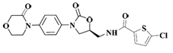
Appearance
Rivaroxaban appears as white to yellowish powder.

Stereochemistry and isomerism
Rivaroxaban has one asymmetric carbon. It shows two isomeric forms. (S)-isomer is therapeutically used.

Manufacturing process
The API rivaroxaban is sourced from two manufacturers. ASMF procedure was used.
QP declaration, issued by the QP of the MIAH site was submitted.

Specifications
The control tests and specifications for drug substance product were adequately drawn up. The specification of the API includes test methods generally in accordance with a recent Ph.Eur. monograph for rivaroxaban (01/2021:2932) and additional tests for XRD, melting point, particle size distribution, residual solvents and microbiological quality.

Stability
The proposed re-test period is 24 months for API sourced from drug substance manufacturer 1 and 36 months for API sourced from drug substance manufacturer 2. The proposed re-test periods are justified on the basis of the data provided in the ASMFs concerned and are accepted.

Medicinal Product

Development of the product
The finished product was developed as a generic to Xarelto film-coated tablets. The product development involved identifying a feasible prototype formulation followed by optimization studies for all the relevant formulation and process parameters. The development of the product was described in sufficient detail.

All of the excipients used are conventional pharmaceutical ingredients that comply with the requirements of EP except coating materials. The coating materials are proprietary materials purchased from a qualified commercial supplier, to an agreed specification. The individual compendial components used in the manufacturing of coating materials comply with the EP/USP-NF monograph.

Manufacturing process
The finished product is manufactured by wet granulation and a detailed description of the process has been provided in the dossier. In brief, it involves manufacturing of granulate by wet granulation, drying of granules, milling, blending, compression and film coating.

Specifications
The product specification includes description, dimensions, identification, dissolution, uniformity of dosage units, assay (HPLC), related substances, water content, microbiological testing and colour identification.
The proposed specification for the finished product is in line with ICH Q6A, where relevant, and is generally acceptable.

Stability
Stability data were provided for four batches of each strength under long-term and accelerated conditions which were packed in PVC/PVdC-Alu blister and HDPE bottle as proposed for marketing. The proposed shelf life of 2 years (180 days after opening the bottle) is considered acceptable. No special storage conditions are applicable.

Non-clinical aspects

Introduction

As rivaroxaban is a widely used, well-known active substance, the Applicant has not provided additional studies and further studies are not required. Overview based on literature review is considered appropriate.

Ecotoxicity/environmental risk assessment (ERA)

Applicant provided a calculation of PEC_{SURFACEWATER} - the calculated PEC_{SURFACEWATER} value was above the limit of 0.01 μg/L. According to the current Guideline on the environmental risk assessment of medicinal products for human use (EMEA/CHMP/SWP/4447/00 corr 21 *), if the PEC_{SURFACEWATER} value is equal to or above 0.01 µg/L, then a Phase II environmental fate and effect analysis should be performed. Therefore Applicant provided commitment regarding ERA - to conduct the Phase II ERA and to submit the results together with the PEC/PNEC calculation via post-authorisation procedure.

Clinical aspects

Introduction

The provided clinical overview on the clinical pharmacology, efficacy and safety was adequate. The proposed indications are in accordance with the reference product.

To support the application, the Applicant has submitted as report 3 bioequivalence studies. A biowaiver was requested for 15 mg formulation of Vixargio based on bioequivalence study with the 20 mg formulation.

Number and type of BE studies is in line with the rivaroxaban product specific guideline (EMA/CHMP/160650/2016), one single dose study under fasting condition with the 10 mg strength and one study under fed conditions with the 20 mg is required, as there is a different food effect resulting in different food recommendations for lower (2.5 and 10 mg) and the higher (15 and 20 mg) strengths.
In addition, Applicant provided the BE study with 2.5 mg since this formulation did not met criteria for biowaiver.

Pharmacokinetics

Biowaiver
The biowaiver request was submitted for 15 mg strength. This is considered acceptable, since all formulation of rivaroxaban are manufactured by the same manufacturing process, the qualitative composition of the different strengths is the same and the composition of the strengths (10 mg, 15 mg and 20 mg) is quantitative proportional (with exception 2.5 mg strength) and in vitro dissolution data has been provided to confirm the adequacy of waiving additional in vivo bioequivalence testing.

Bioequivalence studies

- STUDY NO.: RIRO-TFZ-1001 - rivaroxaban 2.5 mg tablets vs. Xarelto 2.5 mg tablets under fasting conditions. The following pharmacokinetic parameters were computed: C_{max}, AUC_{0-t,} AUC_{0-∞}. The study report does not mention the secondary parameters, however T_{max}, t1/2, and K_{el} were calculated and are presented in the “Results” section.

Table 1: Pharmacokinetic parameters for rivaroxaban
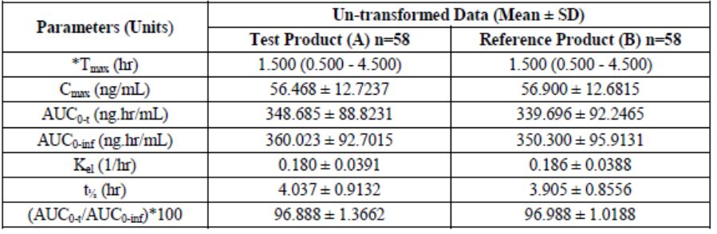

- RIRO-1-19112: rivaroxaban 10 mg tablets vs. Xarelto 10 mg tablets under fasting conditions. The following pharmacokinetic parameters were computed: C_{max}, AUC_{0-t}, AUC0-∞. The study report does not mention the secondary parameters, however T_{max}, t_{1/2}, and K_{el} were calculated and are presented in the “Results” section.

Table 2: Pharmacokinetic parameters for rivaroxaban
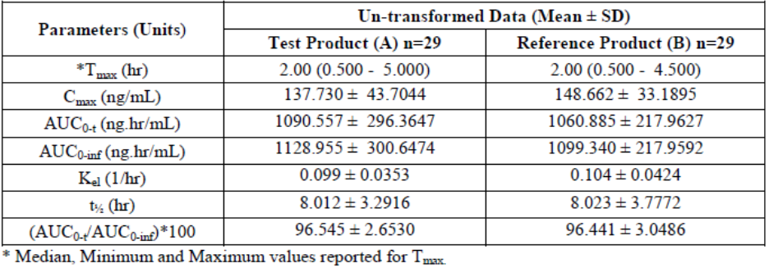

- RIRO-1-19113: rivaroxaban 20 mg tablets vs. Xarelto 20 mg tablets under fed conditions. The following pharmacokinetic parameters were computed: C_{max}, AUC_{0-t}, AUC_{0-∞}. The study report does not mention the secondary parameters, however T_{max}, t_{1/2}, and K_{el} were calculated and are presented in the “Results” section.

Table 3: Pharmacokinetic parameters for rivaroxaban

Conclusion on bioequivalence studies:
Based on the submitted bioequivalence studies, Vixargio is considered bioequivalent with reference medicinal product Xarelto.

Risk Management Plan

The MAH has submitted a risk management plan, in accordance with the requirements of Directive 2001/83/EC as amended, describing the pharmacovigilance activities and interventions designed to identify, characterise, prevent or minimise risks relating to Vixargio.

- Summary table of safety concerns as approved in RMP.
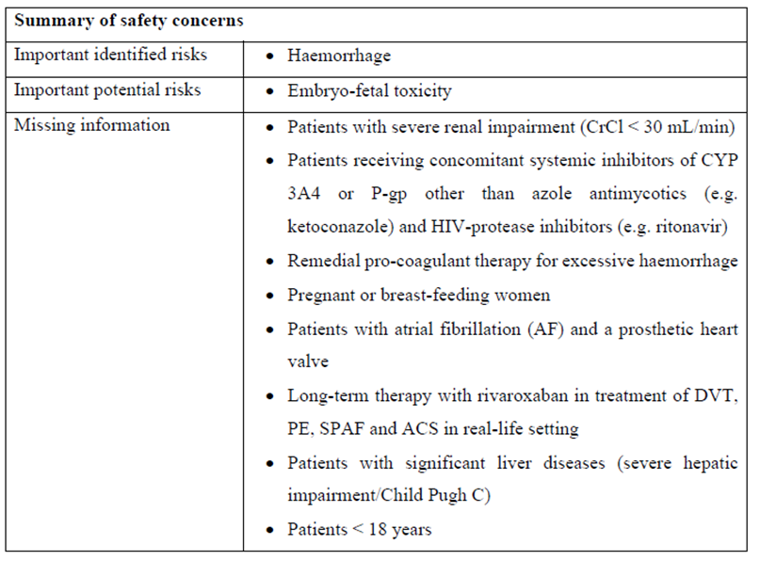

- Summary of Safety Concerns and Planned Risk Minimisation Activities as approved in RMP

The safety information in the proposed product information is aligned to the reference medicinal product. Additional risk minimisation measures are implemented for the Important identified risk Haemorrhage in the form of Educational material for prescribers and Patient Alert Card.

The proposed additional risk minimisation measures are in line with the reference medicinal product and therefore endorsed by the RMS.

Discussion on the clinical aspects

Submitted BE studies demonstrated bioequivalence between tested medicinal product (Vixargio 2.5 mg, 10 mg and 20 mg) and reference medicinal product (Xarelto). Biowaiver for strength 15 mg was requested; submitted data are considered sufficient.

User consultation

A user consultation with target patient groups on the package information leaflet (PIL) has been performed on the basis of a bridging report making reference to PIL 1 of other drug product (bridging for layout/design/format) and PIL 2 of Xarelto (approved via centralised procedure EMEA/H/C/000944 - bridging for content). The bridging report submitted by the applicant has been found acceptable.

Overall conclusion, benefit/risk assessment and recommendation

The benefit risk of this medical product was considered positive. Bioequivalence has been shown to be in compliance with the requirements of European guidance documents.

There was no discussion in the CMD(h). Agreement between member states was reached during a written procedure.

The decentralised procedure was finalised with a positive outcome on 10 March 2022 with one additional risk minimisation measures falling under Article 21a/22 of Directive 2001/83/EC:

-MAH shall provide an educational pack prior to launch, targeting all physicians who are expected to prescribe/use rivaroxaban. The educational pack is aimed at increasing awareness about the potential risk of bleeding during treatment with rivaroxaban and providing guidance on how to manage that risk. The physician educational pack should contain:
• The Summary of Product Characteristics
• Prescriber Guide
• Patient Alert Cards

