CMDh/223/2005
February 2014

Public Assessment Report

Scientific discussion

Vocasept 8.75 mg lozenges
flurbiprofen

SK/H/0280/001/DC

Date: 06/2023

This module reflects the scientific discussion for the approval of Vocasept. The procedure was finalised on 17 March 2023. For information on changes after this date please refer to the module ‘Update’.

Introduction

Based on the review of the quality, safety and efficacy data, the Member States have granted a marketing authorisation for Vocasept 8.75 mg lozenges, from Mapaex Consumer Healthcare (Ireland) Private Limited, Ireland.

The product is indicated for: short-term symptomatic relief of sore throat in adults and children over the age of 12 years.
A comprehensive description of the indications and posology is given in the SmPC.

The marketing authorisation has been granted pursuant to Article 10a of Directive 2001/83/EC.

Quality aspects

Introduction

The drug product is a white to pale yellow coloured, round, flat bevelled lozenge.
Vocasept is available in PVC - PVDC Aluminum blisters in a printed cardboard box with pack sizes 16 and 24 lozenges.

2.2 Drug Substance

Flurbiprofen
Chemical name: (2RS)-2-(2-Fluoro[1,1′-biphenyl]-4-yl)propanoic acid.

Appearance: white or almost white, crystalline powder

Solubility: practically insoluble in water, freely soluble in ethanol (96 per cent) and in methylene chloride. It dissolves in dilute solutions of alkali hydroxides and carbonates.

Chirality: stereo enantiomer is possible - flurbiprofen molecule contain one asymmetric carbon atom. The Ph. Eur. mentions racemic form (2RS)-2- (2-fluorobiphenyl-4-yl) propanoic acid (most stable form)

Manufacturing: Information on the manufacturing process and process controls has been supplied to, and approved by, the European Directorate for the Quality of Medicines (EDQM) in relation to the Certificate of Suitability procedures for Flurbiprofen Ph. Eur. Certificate of suitability Rl-CEP 2003-270-Rev 03 held by Pharmaron manufacturing services (UK) LTD, has been submitted.

Specifications: The specifications of flurbiprofen are in line with the active pharmaceutical ingredient (API) monograph no. 1519 published under Ph. Eur.

Stability: The re-test period approved and assigned for flurbiprofen is three years, as outlined in the Certificate of Suitability.

Medicinal Product

Pharmaceutical development: In order to choose the correct components for the formulation, a study of the components of “over-the-counter (OTC) medicinal products” was carried out. The choice of the components were based mainly on the German reference product Dobendan Direkt Flurbiprofen 8.75 mg Lutschtabletten.

Manufacture of the product: The formulation of finished product Honey Lemon Flurbiprofen lozenges 8.75 mg manufactured by Makson Healthcare Private Limited, India is based on long-term experience of company and literature data. The description of the manufacturing process consists of following steps: preparation of flurbiprofen solution and sugar syrup, cooking, mixing, lozenges former, sorting and packing.

Product specification: The proposed specification parameters and limits for control of the finished product are in line with ICH Q6A, where relevant and Ph. Eur. Monograph no. 1807 Oromucosal preparations.

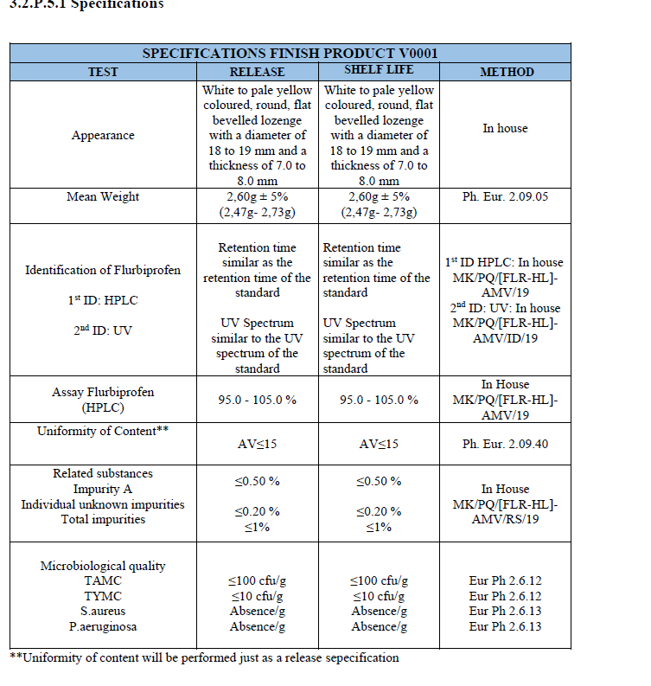
Stability of the product: Stability data were provided for three batches under long-term, intermediate and accelerated conditions which were packed in PVC/PVDC-Al blister (primary packaging). At the time of submission 6 months accelerated study data and 36 months intermediate and long-term stability data are available. The proposed shelf life of 36 months was accepted.

Discussion on chemical, pharmaceutical and biological aspects

From quality point of view the dossier was adequately presented.

Non-clinical aspects

Introduction

The pharmacodynamic, pharmacokinetic, and toxicological properties of flurbiprofen are well known and have been adequately summarised based on publicly available information in the non-clinical overview. A non-clinical overview was based on literature review. The literature referred to approximately 101 publications up to the year 2015. The search strategy was performed by the applicant within the PubMed standard database in March 2021 and covered non-clinical evidence from the late 70’s to present time.

Assessment of GLP aspects was not needed due to the type of application (well established use application).

The non-clinical safety data contained in the proposed SmPC reflects the characteristics of flurbiprofen.

Pharmacology

The applicant has provided a detailed summary of the non-clinical primary pharmacology for the active substance of Vocasept, flurbiprofen. In addition, sections on secondary pharmacology, safety pharmacology, and pharmacodynamics drug interactions have also provided sufficient data.

Pharmacokinetics

The applicant has provided an overview of the non-clinical pharmacokinetics of flurbiprofen based on published literature.

Absorption: A sufficient amount of pharmacokinetic data dedicated to the absorption of active substance as racemate or as respective stereoisomers in multiple relevant species (rats, mice, dogs, monkeys, cows) was provided.

Distribution: The pharmacokinetics of flurbiprofen, together with the low dose and short-term use of flurbiprofen lozenges, results in very limited systemic accumulation of the drug. Flurbiprofen is extensively bound to plasma proteins in rats, dogs, non-human primates (baboons) and humans. Flurbiprofen is distributed and slightly elevated in the rat liver, kidney, large intestine, and thyroid after repeated dosing.

Metabolism: Flurbiprofen forms oxidized metabolites (4-hydroxyflurbiprofen and 3, 4-dihydroxyflurbiprofen) or further methylated metabolites (3-hydroxy-4 methoxyflurbiprofen). The parent compound and metabolites are subsequently glucuronidated or sulfated.

Excretion: Flurbiprofen is excreted in urine and faeces equally in dogs, and renal excretion is dominant in other animal species. Flurbiprofen is capable of undergoing enterohepatic recycling. Elimination half-lives measured 0 to 12 h after a single dose were: mouse 3.4 h, rat 2.5 h, dog 10.1 h, baboon 3.1 h, and man 3.9 h.

Pharmacokinetic drug interaction: There is limited potential for drug interactions to occur after use of flurbiprofen lozenges due to the low dose and the resultant very low blood levels. The author presented a study where the interaction of flurbiprofen and cranberry juice, grape juice, tea, and fluconazole based on the impairment of CYP2C9 activity was investigated in vitro.

Toxicology

Single dose toxicity: LD₅₀ values of doses given orally, intraperitoneally, subcutaneously, and intravenously to mice; orally, intraperitoneally, subcutaneously to rats; orally and dermally to rabbits; and orally to dogs were presented. The concerns about single dose toxicity of this well-known substance are reduced when given oromucousally in this formulation.

Repeat dose toxicity: The repeat dose toxicity studies where flurbiprofen was given repeatedly for 4 days, 30 days (+enantiomers), 3 months, and 2 years in rats were provided. The results showed the gastrointestinal effects, which occurred at comparable doses to the proposed clinical ones, and the kidney effects. These findings are in line with those observed during therapy with other NSAIDs. The previous clinical use of the drug in products containing flurbiprofen supports the view that further non-clinical repeat dose toxicity data are not required.

Genotoxicity: Flurbiprofen was not genotoxic or any DNA damage was detected in the SCE test in human lymphocytes in vivo at a dose of 200 mg/day (2 week treatment period), which is 4.6 times the proposed maximum recommended human dose, or in the CA test or RAPD-PCR test in bone marrows of rats in vivo at any concentrations for 12 and 24 h. No significant increase in oxidative stress was detected in rat peripheral blood (except for 58.50 and 117 mg/kg, 12 h).

Carcinogenicity: Based on the presented literature evidence for flurbiprofen, it could be concluded that the component is not carcinogenic. Moreover, the product is intended for short-term treatment and does not need carcinogenicity studies unless there is cause for concern.

Reproductive and developmental toxicity: At a comparable human dose, flurbiprofen did not affect fertility in rats, but it did increase embryo-foetal lethality and malformations, including cardiovascular abnormalities. Flurbiprofen negatively influenced foetal and organ development and growth. No sufficient evidence of flurbiprofen's effect on postnatal development was provided. In clinical practice during the first and second trimester, flurbiprofen is limited to use where there is no other adequate option. During the third trimester, flurbiprofen is contraindicated. Although flurbiprofen can affect reproduction and development, the clinical treatment is considered to be managed and controlled appropriately.

Local tolerance: Flurbiprofen caused an allergic skin reaction when administered to guinea pigs dermally. This effect is not relevant for the proposed route of administration and, therefore, no further action was needed regarding local tolerance.

Other studies: The flurbiprofen in this formulation is not likely to present a photosafety concern. Considering the presented studies and well-known clinical use, this medicinal product does not likely represent any unknown risk for patients regarding hepatic toxicity. The study provided to demonstrate ocular toxicity in vitro indicated a potential ocular toxicity of flurbiprofen. However, the proposed route of administration of this medicinal product is oromucosal, and for this reason, there was no cause for concern considering ocular toxicity. Flurbiprofen was cytotoxic to bone marrow cells of healthy rats.

Studies on excipients: The applicant identified and toxicologically characterized the inactive ingredients, such as levomenthol, macrogol 400, sucrose, and glucose. The presented excipients are well-known and considered safe to be used at recommended concentrations. Glucose could pose a risk for patients with glucose-galactose malabsorption and DM. The specific composition of honey and lemon flavour were provided.
The components of honey and lemon flavour are considered safe when used in this medicinal product under the recommended dosing regimen. Additional appropriate warnings were included in the SmPC due to the potential for skin irritation from the fragrances in honey (citronellol) and lemon (citral, citronellol, geraniol, limonene, and linalool) flavour.

Studies on impurities: The applicant provided an impurity test for flurbiprofen and no impurity was greater than its respective limits. The active substance, according to the presented certificate, meets the safety requirements.

Ecotoxicity/environmental risk assessment (ERA)

Summary of main study results
Substance (INN/Invented Name): flurbiprofen
CAS-number (if available): 5104-49-4
PBT screening |  | Result | Conclusion
Bioaccumulation potential- log K_{ow} | Experimental  published values (HPLC) | 3.86  3.60 ±0.09 | Not potential PBT (N)
Phase I
Calculation | Value | Unit | Conclusion
PEC _{surfacewater} (default) | 0.22 | mg/L | > 0.01 threshold (Y)
Other concerns (e.g. chemical class) |  |  | (N)

Conclusions on studies:
Given the facts, which indicate that flurbiprofen has the potential to pose a risk to aquatic environment, the adequate statements were included in relevant sections of the SmPC.

Discussion on the non-clinical aspects

Sufficient references to published non-clinical data were provided, therefore, the provisions of article 10a of Directive 83/2001/EC for well-established use were fulfilled.

Clinical aspects

Pharmacokinetics

Pharmacokinetics of flurbiprofen is well-understood and the applicant provided generally sufficient amount of data to substantiate it.

Pharmacodynamics

Mechanism of action of flurbiprofen is well-understood and the applicant provided sufficient amount of literature data to substantiate it.

Clinical efficacy

The applicant submitted 9 references to clinical studies to support the following indication: short-term symptomatic relief of sore throat in adults and children over the age of 12 years. The assessor found 3 more study references.
Taking into account the assessment provided for individual studies, there was evidence showing clinically relevant efficacy of flurbiprofen in the claimed indication.
The studies recruited patients with different severities of sore throat and therefore wide indication for mild, moderate and severe sore throat is acceptable. Short-term treatment is also acceptable as studies used treatment duration up to 7 days when specified in the article. “Symptomatic relief” is also supported as flurbiprofen is not an antiinfective agent.
Flurbiprofen has one chiral center. The active substance within this procedure was racemic mixture Other flurbiprofen containing lozenges on the Slovakian market authorised also through decentralised procedure were also racemic mixtures and therefore different efficacy or safety was not expected in this regard.
The studies did not exclude elderly patients although they did not report separate results for these patients either. The applicant used the following wording in 4.2 for elderly:
Elderly population
Due to the limited clinical trials, available, a general dose cannot be recommended. Elderly patients are at higher risk of suffering serious consequences of adverse reactions.
This was supported and also in line with other products on the market.

The studies included one adolescent patient. Considering that flurbiprofen lozenges are indicated also for adolescents in the EU and that no significant differences in exposure were expected, adolescent indication with adult dose was acceptable.
Lozenges are an acceptable formulation for adolescents.

The applicant proposed the dosing recommendation in line with other products on the market which is generally supported. The applicant decided to limit maximal use to 5 days which was acceptable considering that these lozenges are generally limited to use for few days.
The applicant provided a bridge between the proposed product and the product available on the EU market by means of dissolution study which showed that both products dissolved quickly (over 85% within 15 minutes) which supports their PK similarity. No significant impact of excipients was expected based on the discussion provided by the applicant.

Clinical safety

Flurbiprofen has been used for long time with a well-established safety profile.
The applicant compiled 4.8 to be in line with already approved products on the market. This was generally acceptable.
AEs reported by clinical trials were generally in line with AEs reported in 4.8.
The recommendations on pregnancy, breast-feeding and fertility have been adapted based on CMDh recommendation from July/September 2022.
Clinical trial data on elderly were limited and no separate conclusions were provided for this age group. However, the applicant used warnings in the SmPC on possibly higher incidence of AEs in this age group which is in line with available evidence on NSAIDs and other products on the market. Considering wide experience with flurbiprofen, this point was considered as acceptable.
The contraindications and warnings were in line with professional recommendations and other products on the market.

Risk Management Plan

The MAH has submitted a risk management plan, in accordance with the requirements of Directive 2001/83/EC as amended, describing the pharmacovigilance activities and interventions designed to identify, characterise, prevent or minimise risks relating to Vocasept.

- Summary table of safety concerns as approved in RMP
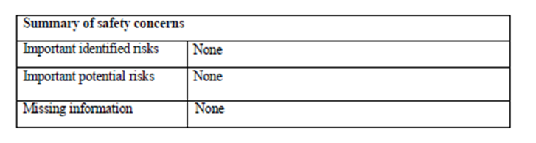

Discussion on the clinical aspects

Sufficient references to published clinical data were provided, therefore, the provisions of article 10a of Directive 83/2001/EC for well-established use were fulfilled.

User consultation

The package leaflet has been evaluated via a user consultation study in accordance with the requirements of Articles 59(3) and 61(1) of Directive 2001/83/EC. The language used for the purpose of user testing the PIL was English.
The results show that the package leaflet meets the criteria for readability as set out in the Guideline on the readability of the label and package leaflet of medicinal products for human use.

Overall conclusion, benefit/risk assessment and recommendation

This decentralised procedure was a well-established use application according to Article 10(a) of Directive 2001/83/EC for Vocasept which contains flurbiprofen as an active substance.

Flurbiprofen is marketed for over decades. Over the years of world-wide use it has been proven that flurbiprofen is effective for pain relief of mild to moderate symptoms of acute sore throat and well tolerated by the patients in different pharmaceutical forms. Flurbiprofen possesses a profile of a safe drug substance, fulfilling the criteria of the well-established medicinal use within the Community for at least ten years.

Applicant adequately demonstrated flurbiprofen´s medicial use referring to publicly available non-clinical and clinical scientific data, thus fulfilling the provisions of article 10a of Directive 2001/83/EC. Quality aspects of the dossier were adequately described; specifications of API flurbiprofen were in line with monograph no. 1519 published under Ph. Eur and that of finished medicinal product were in line with ICH Q6A, where relevant and Ph. Eur. Monograph no. 1807 Oromucosal preparations.

